Burj Al Hawadeet
"Tower of Tales"
(Bedtime Stories)

 |  |  |  |  |  |  | 30 | : | No. of episodes | -
 |  |  |  |  |  | 10 min. |  | : | Duration of each episode | -
 |  |  |  |  |  | 2 : 5 |  | : | Target age | -
2D animation |  |  |  |  |  |  |  | : | Type (style) | -

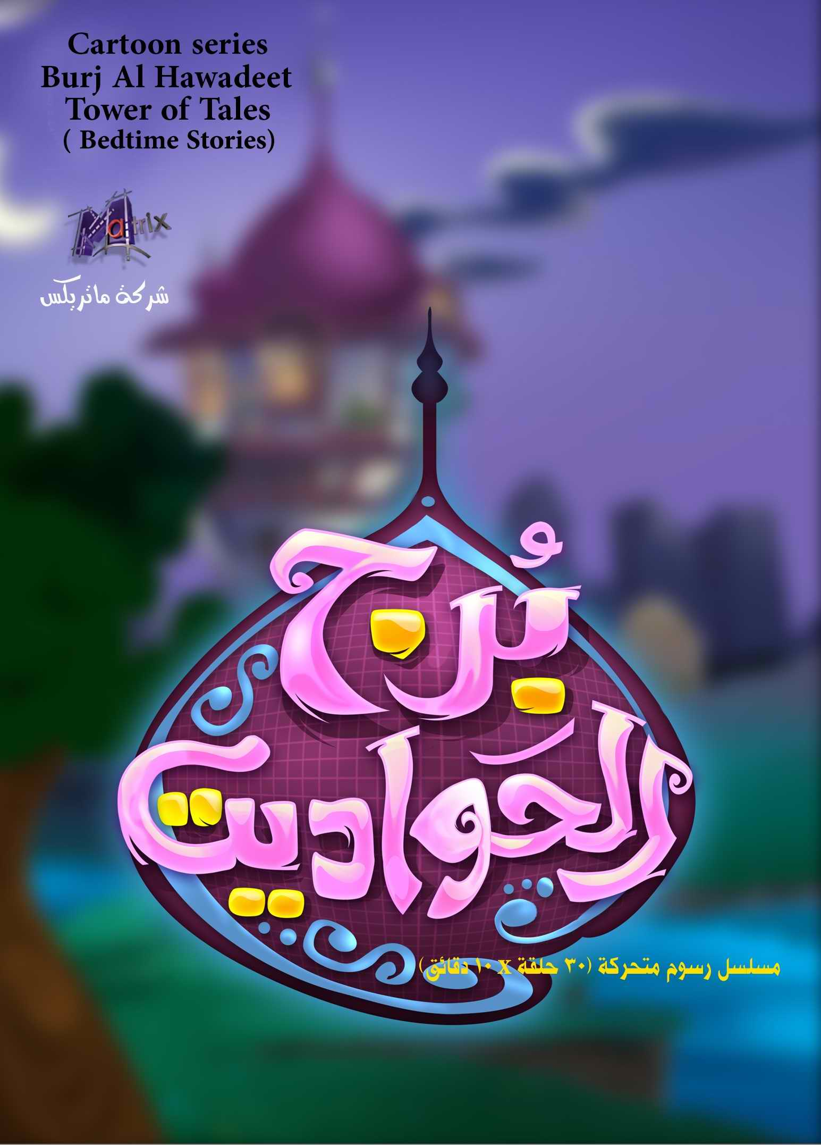

Overview:-

Bedtime stories for little children, told by grandma, with her calm yet exciting voice she manages to take them to a new adventure everyday.
When reality merges with imagination, the stories trigger childrens' different talents and creativity along with the important values and morals.
The stories differ from old to recent times, fiction and nonfiction, stories about people, animals, birds, insects and plants.

* The grandma character appears at the beginning of each episode, explaining to the children the objectives of the story and describing the main characters of the story.

* She starts telling the story and the picture develops into events.
* The grandma illustrates the adventures and emotionally takes the children to the world of fantasy.

* At the end of the story, we return to the grandma were she will emphasize the morals concluded from the story and how we can best use it and benefit from it.

For promo screening; visit our web site (egymatrix.com) or use the following link:
- Episode: Alfeel Zo Alajniha (Elephant with wings): https://youtu.be/q362ddhohlk
- Episode: Al Juhr Al Sagheer (Small Cave): https://youtu.be/OvZd2G71IDs

